TESTING TABLEAU/ POWER BI REPORTS IN SQL
- Create Table
create table hrdata
(
emp_no int8 PRIMARY KEY,
gender varchar(50) NOT NULL,
marital_status varchar(50),
age_band varchar(50),
age int8,
department varchar(50),
education varchar(50),
education_field varchar(50),
job_role varchar(50),
business_travel varchar(50),
employee_count int8,
attrition varchar(50),
attrition_label varchar(50),
job_satisfaction int8,
active_employee int8
)
- Import Data in Table Using Query
COPY hrdata FROM 'D:\hrdata.csv' DELIMITER ',' CSV HEADER;
- Employee Count:
select sum(employee_count) as Total_Employees from hrdata
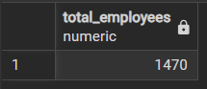

For filter:
select sum(employee_count) as Total_Employees from hrdata
where education = 'High School'
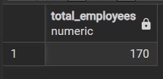
select sum(employee_count) as Total_Employees from hrdata
where department = 'Sales'
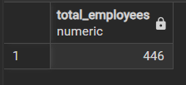
- Attrition Count:
select count(attrition) as attrition_count from hrdata
where attrition = 'Yes'
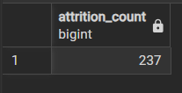
For filter:
select count(attrition) as attrition_count from hrdata
where attrition = 'Yes' and education = 'High School'
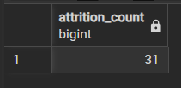
select count(attrition) as attrition_count from hrdata
where attrition = 'Yes' and department = 'R&D' and education_field = 'Medical'
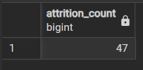
- Attrition Rate:
select round((( select count(attrition) from hrdata where attrition = 'Yes')
/ sum(employee_count))*100 , 2) as attrition_rate from hrdata
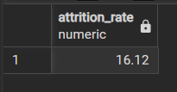
For filter:
select round((( select count(attrition) from hrdata where attrition = 'Yes' and department = 'Sales')
/ sum(employee_count))*100 , 2) as attrition_rate from hrdata
where department = 'Sales'
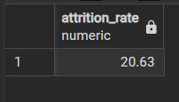
- Active Employee:
select sum(employee_count) - ( select count(attrition) from hrdata where attrition = 'Yes' )
as Active_employees from hrdata
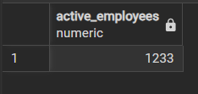
For filter:
select sum(employee_count) - ( select count(attrition) from hrdata where attrition = 'Yes' and gender = 'Male' )
as Active_employees from hrdata
where gender = 'Male'
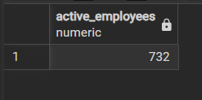

- Average Age:
select round(avg(age), 0) as Average_age from hrdata
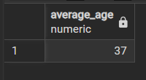
- Attrition by Gender:
select gender , count(attrition) from hrdata
where attrition='Yes'
group by gender
order by count(attrition) desc
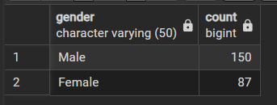
- Department wise Attrition:
select department , count(attrition) , round((Cast(count(attrition) as numeric )/ (select count(attrition) from hrdata where attrition='Yes'))*100 ,2)
from hrdata
where attrition = 'Yes'
group by department
order by count(attrition) desc
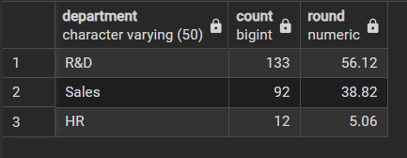
- No of Employee by Age Group
select age , sum(employee_count) as Employee_count from hrdata
group by age
order by age
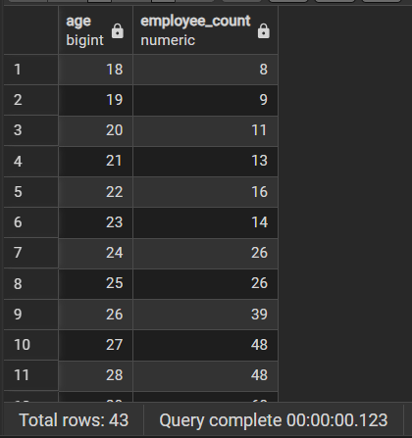
- Education Field wise Attrition:
select education_field, count(attrition) as attrition_count from hrdata
where attrition='Yes'
group by education_field
order by count(attrition) desc;
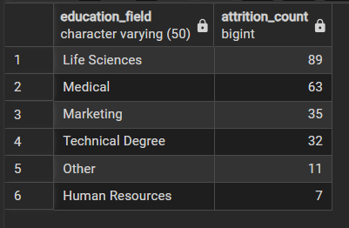
- Attrition Rate by Gender for different Age Group:
select age_band, gender, count(attrition) as attrition,
round((cast(count(attrition) as numeric) / (select count(attrition) from hrdata where attrition = 'Yes')) * 100,2) as pct
from hrdata
where attrition = 'Yes'
group by age_band, gender
order by age_band, gender desc;
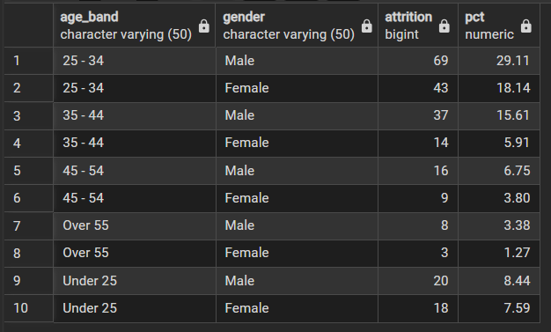

13. Job Satisfaction Rating
-Run this query first to activate the cosstab() function in postgres
CREATE EXTENSION IF NOT EXISTS tablefunc;
Then run this query:
SELECT *
FROM crosstab(
'SELECT job_role, job_satisfaction, sum(employee_count)
FROM hrdata
GROUP BY job_role, job_satisfaction
ORDER BY job_role, job_satisfaction'
) AS ct(job_role varchar(50), one numeric, two numeric, three numeric, four numeric)
ORDER BY job_role;
